Ideation Phase
Empathize & Discover

Date | 3 October 2026
Team ID | SWTID-2026-5226
Project Name | Import Data using Transform Maps (Spreadsheet)
Maximum Marks | 4 Marks

Empathy Map Canvas:
An empathy map is a simple, easy-to-digest visual that captures knowledge about a user’s behaviours and attitudes.
It is a useful tool to helps teams better understand their users.
Creating an effective solution requires understanding the true problem and the person who is experiencing it. The exercise of creating the map helps participants consider things from the user’s perspective along with his or her goals and challenges.
Example:
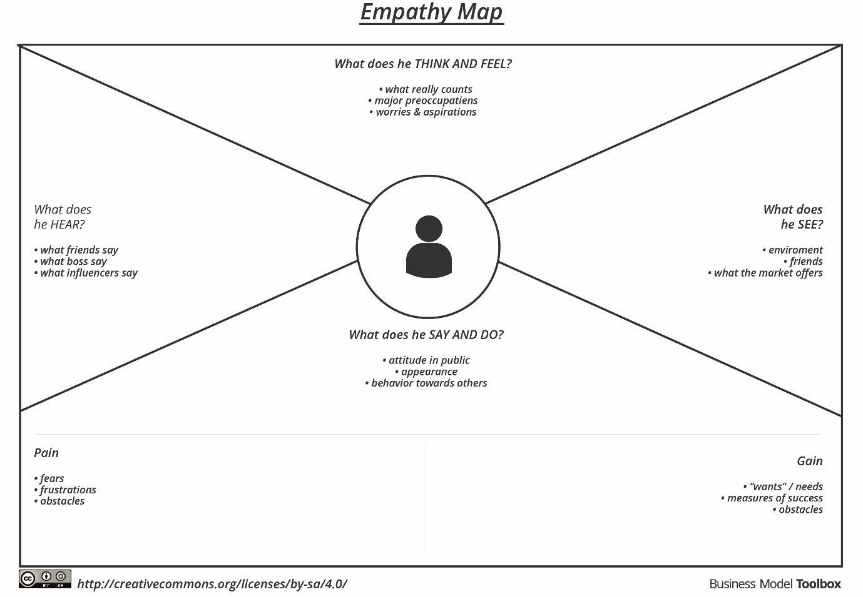
Reference: https://www.mural.co/templates/empathy-map-canvas

Empathy Map: Import Data using Transform Maps (Spreadsheet)
The map below captures what the person importing and reporting on employee data thinks, hears, sees, says and does, along with their pains and gains.
Think & Feel
- Will every row import correctly?
- Worried about wrong or incomplete data reaching the target table
- Wants to be sure repeat imports will not create duplicates
- Hopes the result is something managers can understand quickly
Hear  - Colleagues say the spreadsheet has to be in .xlsx format  - Managers ask for quick numbers, such as employees by department  - Peers advise validating data before it is stored | ServiceNow Administrator  Imports employee data from spreadsheets | See  - A spreadsheet with Employee ID, Name, Email, Department and Location  - Import Set Table rows waiting to be transformed  - Source and target fields on the Transform Map  - Success or error messages after a transform
Say & Do
- Prepares a Google Spreadsheet with sample data and downloads it as .xlsx
- Creates the Employee Test table and its fields, then loads data into an Import Set Table
- Builds a Transform Map and maps source fields to target fields
- Enables Coalesce on a key field and re-imports new data to check updates and inserts
- Creates a pie chart report of employees by department
Pain  - Source columns must be mapped to target fields by hand  - Duplicate records appear when the same data is imported again  - Hard to see what is in the data without a report |  | Gain  - Clean, validated records in the Employee Test table  - Coalesce keeps one record per employee  - Reports and a dashboard give a quick summary

